1. Abstract - at the end

We additionally replicate the experiment on a larger evaluation set of 200 examples, confirming that the observed saturation patterns persist under increased sample size.
2. Introduction - at the end
To verify that these patterns are not artifacts of the small evaluation set, we additionally perform a larger-scale replication experiment using 200 examples.

3.2 Tasks - After the paragraph describing the 20 examples per task:
To assess robustness to dataset size, we additionally run a replication experiment on a larger sample of 200 examples for selected tasks. The replication experiment uses examples sampled from publicly available benchmark datasets while preserving the same prompt templates and evaluation procedure as the main experiment.

3.6 Experimental Scale
The replication experiment evaluates an additional 200 examples per task for a representative model, resulting in approximately 1,400 additional runs per task.

4. Results - Add one new subsection at the end of Results.

4.5 Replication on Larger Dataset - Place this after your main results section.
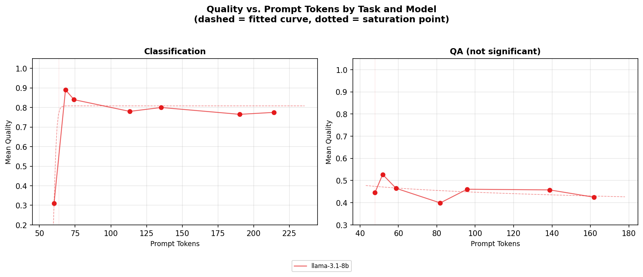
Figure X: Replication experiment using 200 examples. Sentiment classification exhibits a clear saturation pattern, with performance rapidly increasing and then plateauing as prompt tokens increase. In contrast, question answering shows no systematic improvement with longer prompts.
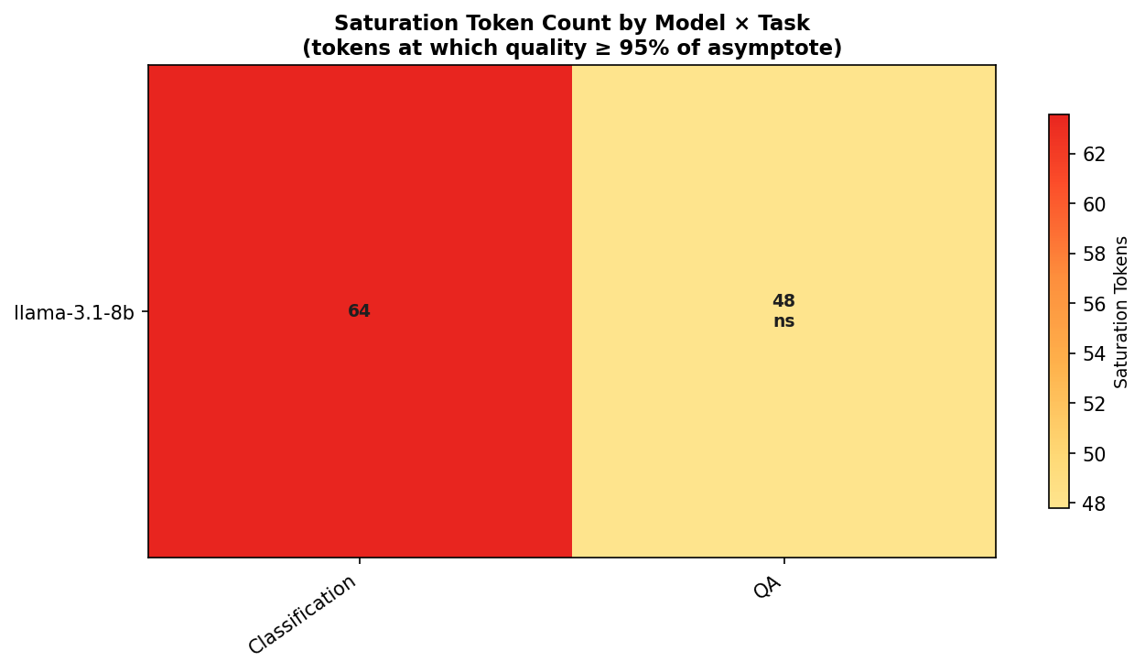Figure Y: Estimated saturation token counts for the replication experiment. Classification saturates at approximately 64 tokens, while no statistically significant saturation point is detected for question answering.

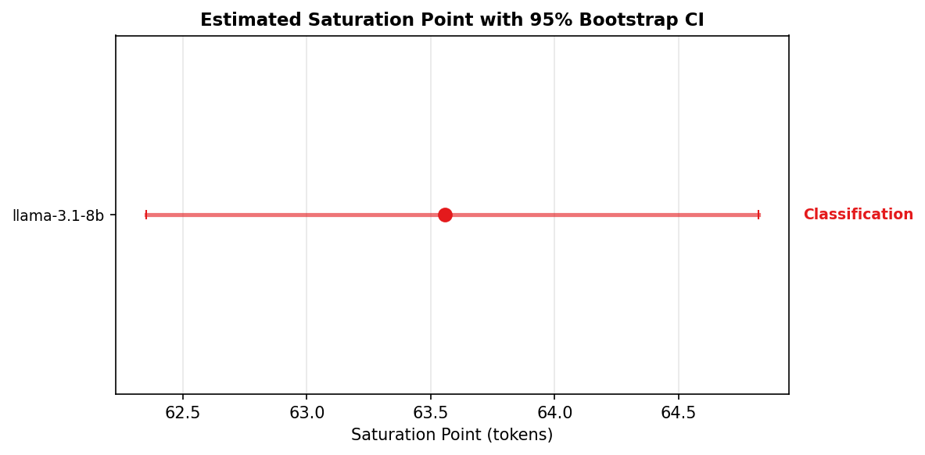
Figure Z: Saturation point estimate for classification with 95% bootstrap confidence interval. The narrow interval indicates that the saturation estimate is stable across resampled evaluation sets.

To verify that the observed saturation behavior is not an artifact of the smaller evaluation set, we replicate the experiment on a larger sample of 200 examples from standard benchmark datasets: SST-2 (Socher et al., 2013) for sentiment classification and SQuAD (Rajpurkar et al., 2016) for question answering. The replication uses the same additive prompt levels, evaluation procedure, and curve-fitting methodology as the main experiment.
Figure X shows the resulting quality–token curves. The classification task again exhibits a clear sigmoid relationship between prompt length and quality, with performance increasing rapidly at low token counts and plateauing afterward. The estimated saturation point occurs at approximately 64 tokens, consistent with the range reported in the main experiment.
In contrast, the question answering task shows no statistically significant relationship between prompt length and response quality. Performance fluctuates across prompt levels without a consistent upward trend, reinforcing the finding that open-ended tasks do not exhibit prompt saturation.
These results confirm that the structured–open task dichotomy observed in the main experiment persists when evaluated on a substantially larger dataset.

6. Discussion
The replication experiment on 200 examples further supports the conclusion that prompt saturation is a stable property of structured tasks rather than an artifact of the smaller evaluation set used in the main experiment.
7. Conclusion
A larger-scale replication confirms that these saturation patterns persist when evaluated on substantially larger datasets.

Reference Citation:
@inproceedings{socher2013recursive,
title={Recursive Deep Models for Semantic Compositionality Over a Sentiment Treebank},
author={Socher, Richard and Perelygin, Alex and Wu, Jean and Chuang, Jason and Manning, Christopher D. and Ng, Andrew Y. and Potts, Christopher},
booktitle={Proceedings of the 2013 Conference on Empirical Methods in Natural Language Processing (EMNLP)},
year={2013},
pages={1631--1642}
}
@inproceedings{rajpurkar2016squad,
title={SQuAD: 100,000+ Questions for Machine Comprehension of Text},
author={Rajpurkar, Pranav and Zhang, Jian and Lopyrev, Konstantin and Liang, Percy},
booktitle={Proceedings of the 2016 Conference on Empirical Methods in Natural Language Processing (EMNLP)},
year={2016},
pages={2383--2392}
}

—-------------------------------------------------------------------------------------------------------------------
Additional edits if you want

There is one sentence pattern in your paper that reviewers commonly attack, and fixing it requires only a tiny wording change.
The issue is overclaiming novelty.
In your paper you currently say something like (paraphrasing from the introduction / related work):
“To our knowledge, no prior work has fitted and statistically tested saturation curves at this level of granularity.”
This type of claim often triggers reviewers to respond:
“The authors claim novelty but related work exists.”
Even if your work is novel, reviewers sometimes interpret this as too strong.

Safer Version (Recommended)
Replace the sentence with this:
Writing
To our knowledge, prior work has not systematically measured quality–token curves using controlled additive prompt levels across multiple tasks and models.
Why this works better:
- avoids absolute claims
- emphasizes methodology
- harder for reviewers to dispute

Another Sentence to Slightly Soften
In the discussion section you argue that:
structured tasks saturate because schema compliance is a discrete capability.
This reads like a confirmed mechanism, but it is actually a hypothesis.
Better wording:
Writing
One possible explanation is that structured-output tasks depend primarily on schema compliance. Once the prompt provides sufficient cues for the model to infer the output schema, additional instruction tokens provide little additional signal.
This frames it as interpretation rather than proof.

Why This Matters
Strong reviewers often look for two things to criticize:
1️⃣ novelty claims
2️⃣ causal claims
These small edits eliminate both risks without weakening your paper.

